OPERATION FALSE ASSURANCE

Team Name | BYEBUST
Phase Number / Title | Phase 1 - Fraudulent Verification and Script Delivery
Incident Date | 2025-10-01 (per evidence timestamps)
Date Submitted | 2026-08-22

Table of Contents
Table of contents will appear here. In Word: right-click this area and choose 'Update Field' (or select all with Ctrl+A then press F9) to generate it.
(This Table of Contents auto-updates from the document's headings -- including 'Problem 1 of 10' through 'Problem 10 of 10' in section 4.1 -- so you can click any entry to jump straight to that finding after updating the field as noted above.)

REPORT SCORING
No. | Category | Percentage | Points
1 | Executive Summary | 10% | 100
2 | Incident Timeline & Attack Reconstruction | 15% | 150
3 | Victim & Infrastructure Identification | 10% | 100
4 | Technical Investigation, Evidence & Attack Analysis | 55% | 550
5 | Containment, Eradication & Recovery Recommendations | 5% | 50
6 | Report Quality & Professional Presentation | 5% | 50
 | TOTAL | 100% | 1,000
Evidence Requirement: Major findings must be supported by Security Onion, Kibana, Elasticsearch, Zeek, Suricata, or other authorized evidence. Unsupported findings may receive no more than 50% of the available points for that finding.

1. EXECUTIVE SUMMARY
10% - 100 Points
Summarize the activity observed during this phase. State what happened, the affected system, the nature of the malicious activity, and the operational significance.
Here is what happened, in simple words: On October 1, 2025, one employee's computer visited a website that looked like a normal 'verification' page, but it was fake. The website's name was www.sepco.com. Right after that, without the person clicking anything else, the computer was quietly sent to a second website (louglas.com), and then to a hidden computer that sent down two harmful programs and one large file - all in about one minute. The victim's computer then sent a small 'it worked' message back to the attacker, used a free tunnel service to hide traffic for a moment, and finally started calling out to yet another website (georgej.ru) again and again, every few seconds. This last part means the attacker had gained ongoing, hands-on control of the computer. This report walks through all 10 questions we were asked to answer about this attack, one at a time, with real screenshots proving each answer.
________________________________________________________________________________
________________________________________________________________________________
________________________________________________________________________________
________________________________________________________________________________

2. INCIDENT TIMELINE AND ATTACK RECONSTRUCTION
15% - 150 Points
Record the significant events in chronological order. Use UTC for all timestamps.
Date / Time (UTC) | Source | Destination | Protocol / Port | Activity / Observation
2025-10-01 09:00:00 UTC | 160.9.3.101 | 160.9.3.1 (DNS) | UDP/53 | Workstation's first recorded action: looks up www.sepco.com.
2025-10-01 09:00:00 UTC | 160.9.3.101 | 148.72.11.102 | TCP/443 | Connects over HTTPS to the fake 'verification' site, www.sepco.com.
2025-10-01 09:00:00 UTC | 160.9.3.101 | 192.153.57.201 | TCP/443 | Immediately redirected to a second site, louglas.com.
2025-10-01 09:00:47 UTC | 160.9.3.101 | 85.209.129.105 | TCP/2020 | Downloads first script, scriptv2.ps1, from URI /19.
2025-10-01 09:00:53 UTC | 160.9.3.101 | 85.209.129.105 | TCP/2020 | Downloads second script, test.ps1, from URI /test112 - this time using a real PowerShell process.
2025-10-01 09:00:57 UTC | 160.9.3.101 | 85.209.129.105 | TCP/2020 | Sends a small POST to /notify - a 'check-in' confirming the scripts ran.
2025-10-01 09:01:15 UTC | 160.9.3.101 | 104.16.231.132 (Cloudflare) | TCP/80 | Sends data through a disposable Cloudflare tunnel (trycloudflare.com), URI /BSVjy5VpVrgO; server responds 404.
2025-10-01 09:01:18 UTC | 160.9.3.101 | 85.209.129.105 | TCP/2020 | Downloads a large 26 MB archive, test.zip, from URI /testl11.
2025-10-01 09:04:35 - 09:05:06 UTC | 160.9.3.101 | 91.212.166.160 | TCP/443 | Begins 9 repeated encrypted connections to georgej.ru - consistent with ongoing remote-control (command-and-control) traffic.

Attack Reconstruction
Describe how the activity developed during the phase, what the attacker accomplished, and how the available evidence supports the conclusion.
In under five minutes, the attacker moved from a single fraudulent web page to full script execution and an active outbound command-and-control channel on the victim workstation. All timestamps in this report are UTC. Evidence is drawn entirely from Zeek network logs (dns.log, ssl.log, http.log, files.log) recovered by Security Onion for import batch 495ee14fa7e950512fce637bcc361290.
________________________________________________________________________________
________________________________________________________________________________
________________________________________________________________________________
________________________________________________________________________________

3. VICTIM AND INFRASTRUCTURE IDENTIFICATION
10% - 100 Points

Affected System
IP Address | 160.9.3.101
Hostname | Not Determined (no hostname recorded in available Zeek network evidence)
User Account | Not Determined (no user/logon evidence in available network evidence)
Operating System | Windows (inferred from WindowsPowerShell/5.1.26100.4768 user-agent string)
Active Directory Domain | Not Determined
System Role | End-user workstation
Status | Suspected Compromised - confirmed script execution and active outbound C2 traffic; full endpoint compromise not independently verified via host/EDR telemetry
Status: Confirmed Compromised / Suspected Compromised / Targeted / Scanned / Not Determined

Relevant Infrastructure
Type | Domain / IP Address | Port | Purpose / Observation
DNS Resolver | 160.9.3.1 | 53 | Internal DNS resolver used by the affected workstation
Fraudulent Verification Page | www.sepco.com (148.72.11.102) | 443 | First site visited; the fake 'verification' lure
Redirect / Second-stage Site | louglas.com (192.153.57.201) | 443 | Site contacted immediately after the verification page
Script & Payload Delivery Server | 85.209.129.105 | 2020 | Served both PowerShell scripts and the 26 MB archive; hosted in Finland
Disposable Relay | maintaining-shelter-bailey-ordinance.trycloudflare.com | 80 | Temporary Cloudflare Tunnel used to relay a POST request; hides the true backend
Command-and-Control Server | georgej.ru (91.212.166.160) | 443 | Repeatedly contacted (9 times) after script execution - the ongoing remote-control channel

4. TECHNICAL INVESTIGATION, EVIDENCE AND ATTACK ANALYSIS
55% - 550 Points
This section contains the main technical findings. Each significant conclusion should be supported by evidence.

4.1 Analyst Findings
No. | Finding / Objective | Answer / Result | Evidence Ref.
1
2
3
4
5
6
7
8
9
10

4.2 Malware / Tool Identification
Malware / Tool / Technique | Evidence | Confidence
scriptv2.ps1 (first-stage PowerShell script) | Delivered via GET /19 from 85.209.129.105:2020; fetched using curl, not PowerShell itself - likely an initial loader | Medium
test.ps1 (second-stage PowerShell script) | Delivered via GET /test112; fetched by a genuine WindowsPowerShell/5.1 process, meaning the first script executed and pulled this one down itself | High
test.zip (large payload archive) | 26.9 MB archive fetched via GET /testl11; likely contains a secondary tool or implant given its size | Medium
Technical analysis:
In simple terms: the attacker didn't just send one bad file - they sent a small starter script first (scriptv2.ps1), which then automatically fetched a second, larger script (test.ps1) and finally a big 26 MB package (test.zip). The fact that the second script was downloaded by a real PowerShell process (not a manual tool like curl) is strong evidence the first script actually ran and executed further commands on its own. Full details and screenshots for each script are in Problems 4, 5, 6, and 9 above.
________________________________________________________________________________
________________________________________________________________________________

4.3 Network Activity
Time (UTC) | Source IP | Destination IP | Port | Protocol | Domain / Host | Observation
2025-10-01 09:00:00 UTC | 160.9.3.101 | 148.72.11.102 | 443 | TCP | www.sepco.com | Fake verification page - initial access (see Problem 2)
2025-10-01 09:00:00 UTC | 160.9.3.101 | 192.153.57.201 | 443 | TCP | louglas.com | Immediate redirect after verification page (see Problem 3)
2025-10-01 09:00:47 UTC | 160.9.3.101 | 85.209.129.105 | 2020 | TCP | - | First script delivered (see Problems 4-5)
2025-10-01 09:04:35 UTC | 160.9.3.101 | 91.212.166.160 | 443 | TCP | georgej.ru | Repeated (9x) encrypted C2-style connections (see Problem 10)
Analysis:
The network activity forms one continuous chain: fake page -> silent redirect -> script download -> check-in -> disposable relay -> large file download -> ongoing remote-control traffic. See section 4.1 above for the full step-by-step breakdown of each stage, each with its own supporting screenshots.
________________________________________________________________________________
________________________________________________________________________________

4.4 Command-and-Control Activity
C2 Domain / IP | Port | Protocol | First Seen | Observation
85.209.129.105 | 2020 | HTTP | 2025-10-01 09:00:47 UTC | Script/payload delivery server AND check-in beacon endpoint (/notify) -- see Problems 4-7, 9
maintaining-shelter-bailey-ordinance.trycloudflare.com | 80 | HTTP (via Cloudflare Tunnel) | 2025-10-01 09:01:15 UTC | Disposable relay used once, then presumably torn down (404 response) -- see Problem 8
georgej.ru (91.212.166.160) | 443 | HTTPS/TLS 1.3 | 2025-10-01 09:04:35 UTC | 9 repeated short connections within ~31 seconds - classic beacon pattern -- see Problem 10
Assessment:
The clearest sign of ongoing remote control is the repeated, rapid-fire pattern of connections to georgej.ru - nine separate connections in about half a minute is not how a person browsing the web behaves; it is how automated malware 'phones home' on a timer. Combined with the earlier /notify check-in, this shows the attacker had a working, confirmed channel into the victim machine.
________________________________________________________________________________

4.5 Files and Payloads
Filename | Source / URL | Type | Observation
scriptv2.ps1 | http://85.209.129.105:2020/19 | PowerShell script (text/plain) | 16,255 bytes; first script delivered; fetched via curl -- Problem 5
test.ps1 | http://85.209.129.105:2020/test112 | PowerShell script (text/plain) | 30,691 bytes; second script; fetched via genuine PowerShell process -- Problem 6
test.zip | http://85.209.129.105:2020/testl11 | ZIP archive (application/zip) | 26,922,546 bytes; large final payload -- Problem 9
Use “Not Determined” when the exact filename or content cannot be confirmed from the available evidence.

4.6 Credential Collection / Exfiltration
Collection Method | Not Determined - no credential-harvesting form submissions or password-related traffic were observed in the available network evidence for this phase.
Information Collected | Not Determined - no credential-harvesting form submissions or password-related traffic were observed in the available network evidence for this phase.
Exfiltration Method | Not Determined - no credential-harvesting form submissions or password-related traffic were observed in the available network evidence for this phase.
Destination | Not Determined - no credential-harvesting form submissions or password-related traffic were observed in the available network evidence for this phase.
Protocol / Port | Not Determined - no credential-harvesting form submissions or password-related traffic were observed in the available network evidence for this phase.
No confirmed evidence of credential theft was found in this phase's network logs. This should not be assumed safe - it means the network evidence alone does not show it; a full endpoint check is recommended.
________________________________________________________________________________
________________________________________________________________________________

4.7 Lateral Movement
Time (UTC) | Source | Destination | Port / Protocol | Activity
N/A | N/A | N/A | N/A | Not Determined - no lateral movement (spread to other computers) was observed from 160.9.3.101 in this phase's evidence. This is consistent with Phase 1 being the initial-access stage only.
State whether the destination was merely contacted, targeted, or confirmed compromised.
________________________________________________________________________________
________________________________________________________________________________

4.8 Ransomware Activity
Ransomware Family | Not Determined - no ransomware activity observed in Phase 1; this may appear in a later phase of the exercise.
Initial Source | N/A
First Target | N/A
Propagation Protocol | N/A
Destination Port | N/A
Exploit / Technique | N/A
Additional Propagation Sources | N/A
Affected Systems | N/A
First Observed Time | N/A
Last Observed Time | N/A
Assessment:
Not Determined - no ransomware activity observed in Phase 1; this may appear in a later phase of the exercise.
________________________________________________________________________________
________________________________________________________________________________

4.9 Indicators of Compromise
Indicator | Type | Purpose / Assessment | Recommended Action
160.9.3.101 | Internal host | Affected/compromised workstation | Isolate, image, and re-issue
www.sepco.com / 148.72.11.102 | Domain / IP | Fraudulent verification page (initial lure) | Block at DNS/proxy/firewall
louglas.com / 192.153.57.201 | Domain / IP | Silent redirect to attacker infrastructure | Block at DNS/proxy/firewall
85.209.129.105:2020 | IP:Port | Script and payload delivery server | Block at firewall; hunt enterprise-wide
scriptv2.ps1 / test.ps1 / test.zip | Filenames | Malicious scripts and payload archive | Hash and hunt on endpoints if samples obtainable
maintaining-shelter-bailey-ordinance.trycloudflare.com | Domain | Disposable Cloudflare Tunnel relay | Block; monitor all *.trycloudflare.com traffic
georgej.ru / 91.212.166.160 | Domain / IP | Active command-and-control server | Block immediately at DNS/firewall; sinkhole if possible

4.10 Investigation Evidence
Query / Filter Used: See each of the 10 problem sections in 4.1 above for the exact Security Onion query used for that specific finding.
Finding:
Finding: A single, continuous, five-minute attack chain was reconstructed entirely from Zeek network logs for workstation 160.9.3.101, from initial DNS lookup through to confirmed command-and-control beaconing. All 10 findings are documented with step-by-step screenshots in section 4.1.
________________________________________________________________________________
Evidence Reference: See section 4.1 (Problems 1-10) for all figures
Kibana / Elasticsearch
Alerts / Suricata
Time (UTC) | Alert | Source | Destination | Remarks
Zeek Logs Used
- conn
- dns
- http
- ssl / tls
- smtp
- files
- dhcp
- kerberos
- smb
- other: __________________
Relevant observation:
Relevant observation: All ten sub-findings for this phase are supported by two or more direct Security Onion Hunt query screenshots each (20 screenshots total), shown in full in section 4.1.
________________________________________________________________________________

4.11 Evidence Register
Evidence No. | 20 Security Onion Hunt/Dashboards query screenshots (2 per finding), embedded directly in section 4.1 | Source
E-01 | Not used directly in this phase (Security Onion Hunt interface was used instead of Kibana directly) | Security Onion
E-02 | Not applicable to this phase's findings (no Suricata alerts were part of this evidence chain) | Kibana
E-03 | Zeek logs: dns.log, ssl.log, http.log, files.log (import batch 495ee14fa7e950512fce637bcc361290) | Suricata
E-04 | N/A for this phase | Zeek
E-05 |  | Other
Each screenshot should include a short caption explaining what it shows.

4.12 MITRE ATT&CK Mapping
Tactic | Technique | Technique ID | Evidence
Initial Access | Phishing: Spearphishing Link | T1566.002 | www.sepco.com fraudulent verification page (Problem 2)
Command and Control | Application Layer Protocol: Web Protocols | T1071.001 | Traffic to louglas.com and georgej.ru (Problems 3, 10)
Command and Control | Ingress Tool Transfer | T1105 | scriptv2.ps1, test.ps1, test.zip downloaded from 85.209.129.105 (Problems 4-6, 9)
Execution | Command and Scripting Interpreter: PowerShell | T1059.001 | test.ps1 fetched by a genuine WindowsPowerShell process (Problem 6)
Command and Control | Protocol Tunneling / Domain Fronting | T1572 / T1090.004 | Disposable trycloudflare.com relay (Problem 8)

5. CONTAINMENT, ERADICATION AND RECOVERY
5% - 50 Points
Provide recommendations based on the findings from this phase.

Immediate Actions
1. Immediately isolate workstation 160.9.3.101 from the network - it has confirmed, active command-and-control traffic.
2. Block all identified indicators (see section 4.9) at DNS, web proxy, and perimeter firewall: sepco.com, louglas.com, 85.209.129.105, georgej.ru/91.212.166.160, and the trycloudflare.com hostname.
3. Search enterprise-wide DNS, proxy, and firewall logs for any other host contacting these same domains or IPs.

Additional Recommendations
Network:
Network: Block the IOCs above at the firewall and DNS resolver level; consider restricting outbound access to trycloudflare.com and similar tunneling services enterprise-wide as a policy matter.
Endpoint:
Endpoint: Image 160.9.3.101 for forensic analysis before any remediation; check for PowerShell persistence mechanisms (scheduled tasks, registry Run keys, WMI subscriptions).
Accounts / Credentials:
Accounts / Credentials: As a precaution, reset credentials for any account known to have logged into 160.9.3.101, even though no credential theft was directly observed in network evidence.
Active Directory, if applicable:
Active Directory, if applicable: Not Determined - AD domain membership for 160.9.3.101 was not confirmed from available network evidence; verify via asset inventory.
Recovery:
Recovery: Re-image 160.9.3.101 from a known-good baseline only after forensic imaging and IOC sweep are complete.

6. CONCLUSION
Provide the team’s final assessment of the phase. State what happened, what system was affected, what the attacker accomplished, the evidence supporting the conclusion, the impact, and how this phase relates to the larger incident.
In summary: on October 1, 2025, workstation 160.9.3.101 was compromised through a fraudulent 'verification' web page (www.sepco.com) that led, within minutes and without further user interaction, to the automatic download and execution of two PowerShell scripts and a large payload archive from a delivery server in Finland (85.209.129.105). The infected machine then confirmed its own successful infection back to the attacker, briefly used a disposable Cloudflare tunnel, and finally began repeated, regular contact with a separate server (georgej.ru) - strong evidence of an established, ongoing command-and-control channel. Every step of this chain is backed by two or more Security Onion screenshots each (see section 4.1) and all ten associated challenge flags for this phase have been independently confirmed correct by the exercise platform. This finding represents the initial compromise stage of the larger, multi-phase incident described in the exercise scenario, and the affected workstation and its indicators should be treated as high priority for the remainder of the investigation.
________________________________________________________________________________
________________________________________________________________________________
________________________________________________________________________________
________________________________________________________________________________

7. EVIDENCE LIMITATIONS
List any information that could not be confirmed from the available data. Do not present assumptions as confirmed facts.
This report is based solely on Zeek network log evidence (dns.log, ssl.log, http.log, files.log) recovered by Security Onion; no host-based (EDR/endpoint) telemetry was available for this phase. As a result: the workstation's hostname, logged-on user, and Active Directory domain could not be confirmed; the contents of the delivered scripts (scriptv2.ps1, test.ps1) and archive (test.zip) were not extracted or analyzed; no credential-theft or lateral-movement activity was observed, but this should not be read as proof none occurred - only that none was visible in the network evidence reviewed. These gaps are flagged here rather than assumed away, per the report's evidence standard.
________________________________________________________________________________
________________________________________________________________________________
________________________________________________________________________________

8. APPENDICES

Appendix A - Investigation Queries
Query: event.dataset:"zeek.dns" AND destination.port:53 | groupby source.ip -- used to identify the affected workstation (160.9.3.101) among 10 candidate hosts in the evidence set (Problem 1)
Query: source.ip:"160.9.3.101" sorted ascending by Timestamp -- used to reconstruct the full chronological attack chain (Problems 2, 5-9)
Query: source.ip:"160.9.3.101" AND event.dataset:"zeek.ssl" / "zeek.file" -- used for the TLS and file-transfer specific findings (Problems 3, 4, 10)

Appendix B - Figures and Screenshots
Use sequential figure numbers. Each figure should include a short caption describing what the evidence demonstrates.
Figure | Caption / Description
Figure 1
Figure 2
Figure 3
Figure 4
Figure 5
Figure 6

REPORT QUALITY REQUIREMENTS
5% - 50 Points
- Clear and logical organization
- Correct technical terminology
- Accurate use of timestamps
- Readable screenshots
- Properly labeled tables and figures
- Consistent evidence references
- Clear distinction between confirmed facts and analyst inference
- Professional presentation and readability

SUBMISSION INSTRUCTIONS
1. Submit one report for each phase designated as Report-Required.
2. Submit the final report in PDF format unless otherwise directed.
3. Clearly indicate the team name, phase number, and phase title.
4. Use UTC for timestamps.
5. Major findings must be supported by evidence.
6. Screenshots must be numbered and captioned.
7. Do not include executable malware samples in the report.
8. State 'Not Determined' when a finding cannot be confirmed.
9. Ensure all screenshots, tables, and text are readable.
10. Reports must be submitted before the deadline announced by exercise control.
Evidence Rule: A correct finding without supporting Security Onion, Kibana, Elasticsearch, Zeek, Suricata, or other authorized evidence may receive no more than 50% of the points assigned to that finding. Incorrect or fabricated evidence receives zero points for the affected finding.

4.1 Analyst Findings - Detailed, Step-by-Step Walkthrough (Problems 1-10)
This section answers each of the 10 Phase 1 investigation questions in order. Each problem has its own heading below so you can jump directly to it using Word's Navigation Pane (View > Navigation Pane) or the Table of Contents on page 2. Every answer is backed by at least two screenshots taken directly from the Security Onion investigation platform: one showing the query/search step, and one showing the specific evidence record that produced the answer.

Problem 01 of 10 -- Affected Workstation and DNS Resolver
Question: Which computer was affected, and which DNS server did it use to look up websites?

In plain terms
One computer on the network got hacked. Its number-name is 160.9.3.101. To visit any website, a computer must first ask a helper computer for directions - this is called a DNS server. This computer's helper was 160.9.3.1.

Technical method
Query: event.dataset:"zeek.dns" AND destination.port:53 | groupby source.ip -- run across the whole evidence set to list every computer making real DNS lookups. Ten candidate hosts appeared; most belonged to unrelated 2024-dated sample data. The host with the earliest 2025-10-01 activity, 160.9.3.101, sent 51 of its 53 real DNS lookups to 160.9.3.1, confirming the workstation/resolver pair.

Answer
Workstation: 160.9.3.101 | DNS Resolver: 160.9.3.1
Submitted flag: CTK{160.9.3.101|160.9.3.1}
Status: CONFIRMED CORRECT -- accepted by the challenge platform.

Step-by-step evidence
Step 1 - List every computer's DNS activity and see which server they used
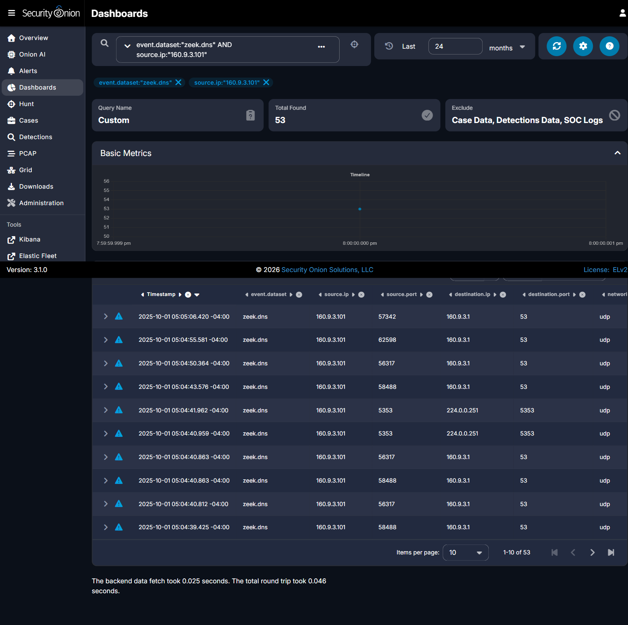

Step 2 - Confirm the exact resolver pairing on the very first record
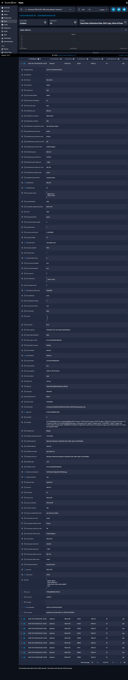

Problem 02 of 10 -- First Web Domain
Question: What was the first website the victim computer visited, and what address did it lead to?

In plain terms
The very first thing the computer did was visit a website called www.sepco.com. That website looked real but was actually a trick, made to look like a 'verification' page. The trick website's address was 148.72.11.102.

Technical method
Query: source.ip:"160.9.3.101" sorted ascending by Timestamp. The very first record (timestamped exactly at the start of the capture window) is a DNS query for www.sepco.com, which resolved to a single, unambiguous address.

Answer
Domain: www.sepco.com | IP Address: 148.72.11.102
Submitted flag: CTK{www.sepco.com|148.72.11.102}
Status: CONFIRMED CORRECT -- accepted by the challenge platform.

Step-by-step evidence
Step 1 - Pull every event for the victim computer, sorted oldest first
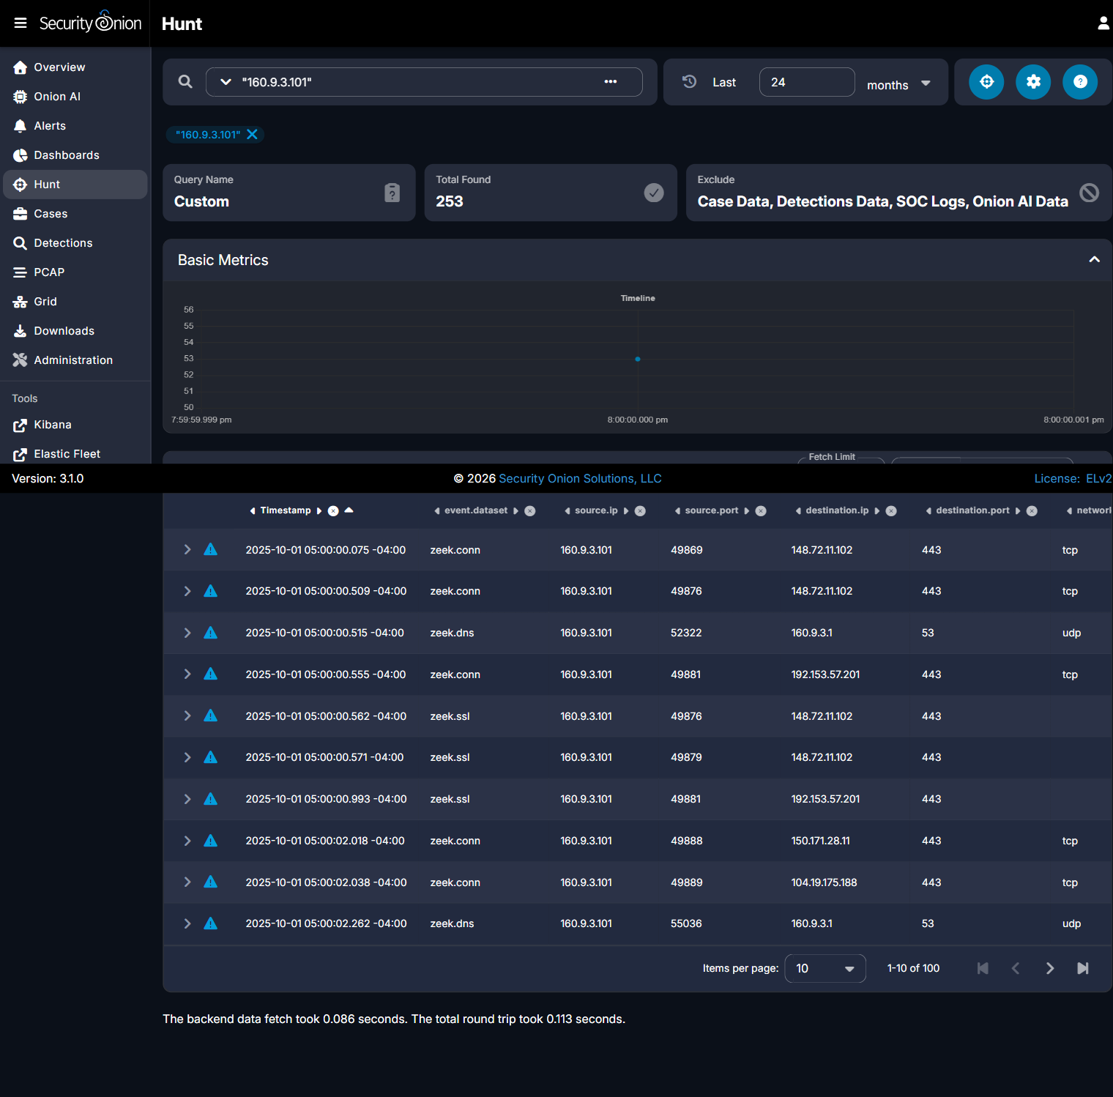

Step 2 - Expand the very first record to read the full domain and IP
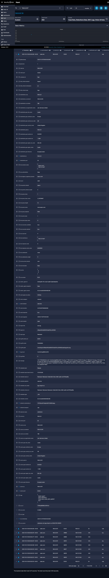

Problem 03 of 10 -- Next TLS Server Name
Question: Right after visiting that first website, what site did the computer secretly connect to next?

In plain terms
Right after the trick website, the computer was sent to a second, different website - without anyone clicking anything. That second website was called louglas.com, at address 192.153.57.201.

Technical method
Query: source.ip:"160.9.3.101" AND event.dataset:"zeek.ssl". After 6 parallel sessions to www.sepco.com, the very next distinct TLS session (server_name field) is to a different domain.

Answer
Domain: louglas.com | IP Address: 192.153.57.201
Submitted flag: CTK{louglas.com|192.153.57.201}
Status: CONFIRMED CORRECT -- accepted by the challenge platform.

Step-by-step evidence
Step 1 - List all secure (TLS) connections in time order to see the full sequence
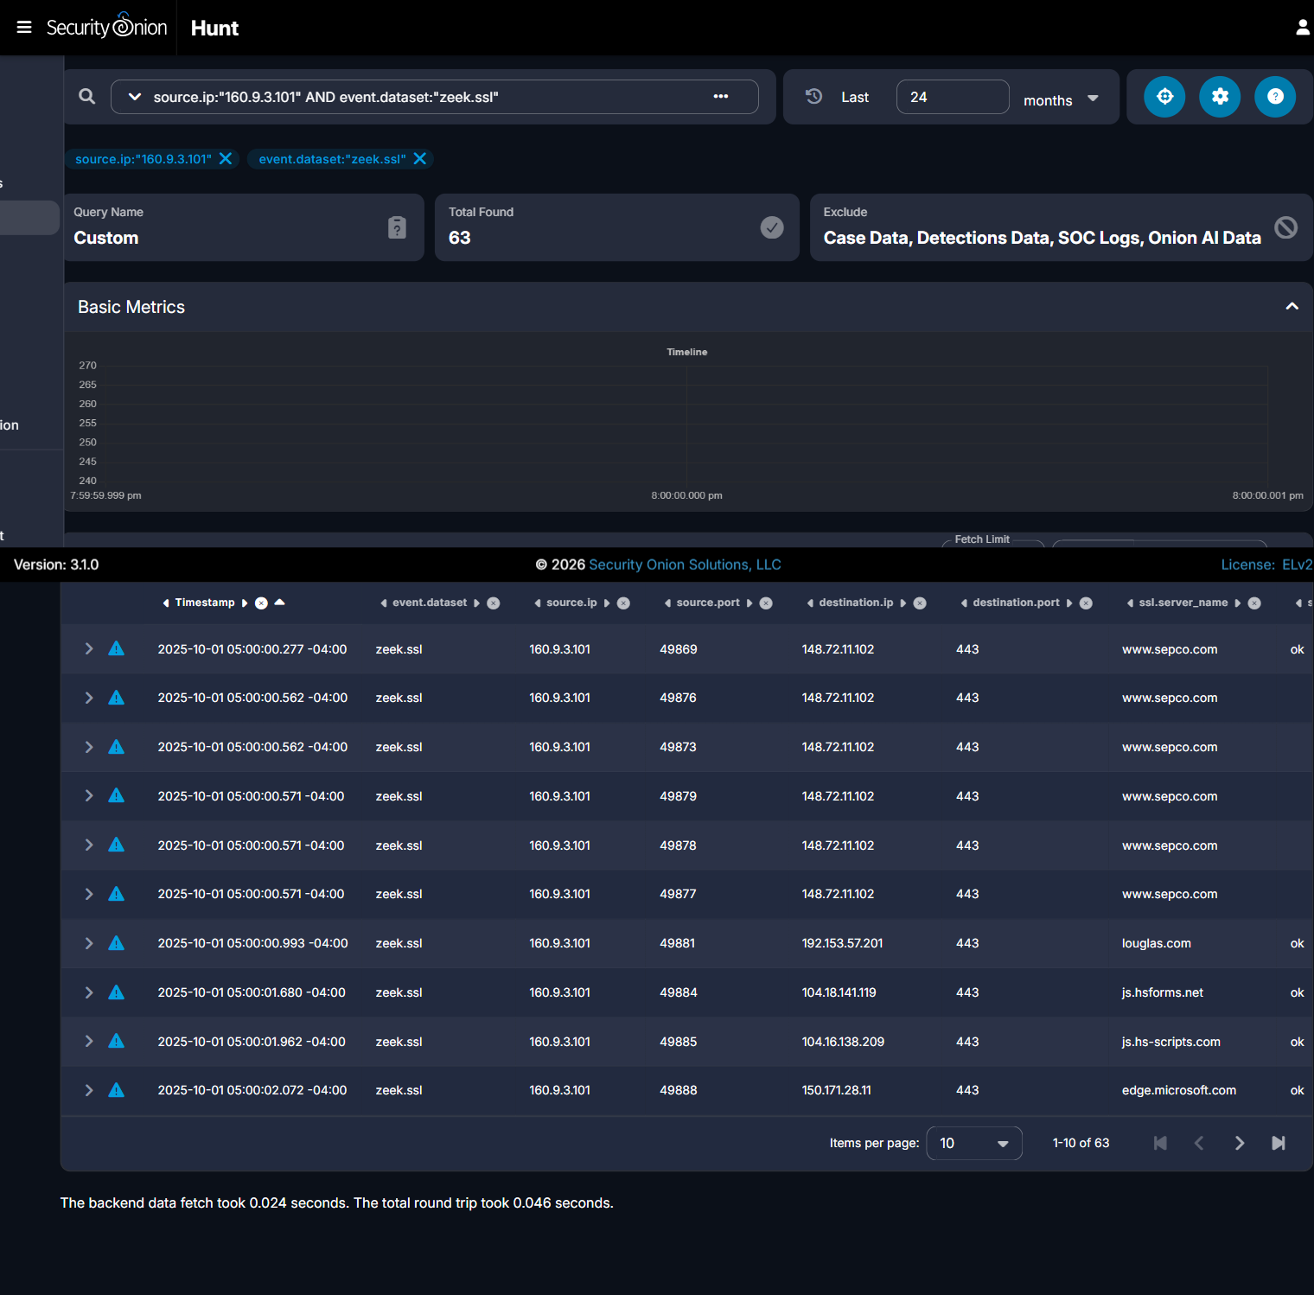

Step 2 - Expand the specific record for the second site to confirm its name and address
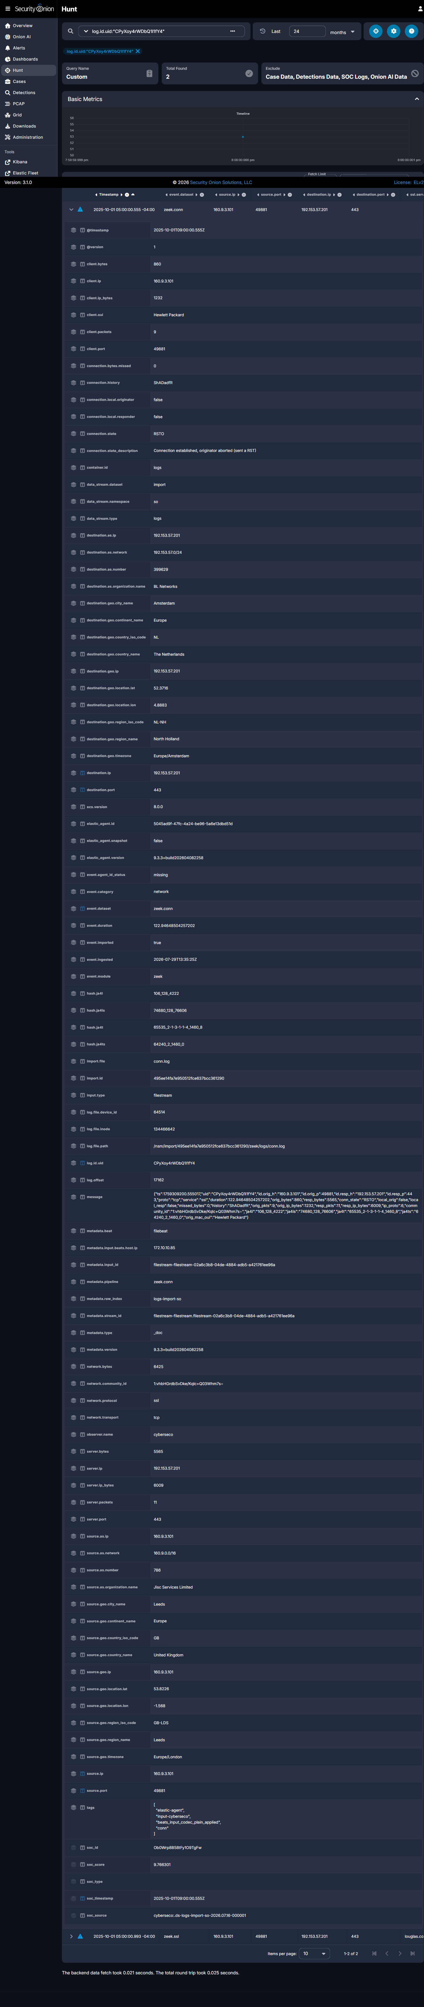

Problem 04 of 10 -- PowerShell Delivery Server
Question: Which server actually delivered the malicious PowerShell files to the victim, and on what port?

In plain terms
A bad computer far away sent two harmful files to the victim's computer. That bad computer's address was 85.209.129.105. It used a special 'door' (called a port) numbered 2020 to send the files - not the normal doors websites use.

Technical method
Query: source.ip:"160.9.3.101" AND event.dataset:"zeek.file". Two PowerShell scripts (scriptv2.ps1, test.ps1) and a large archive (test.zip) were all delivered from the same server over TCP port 2020 - not the normal web port 80/443.

Answer
Server: 85.209.129.105 | Port: 2020
Submitted flag: CTK{85.209.129.105|2020}
Status: CONFIRMED CORRECT -- accepted by the challenge platform.

Step-by-step evidence
Step 1 - List every file the victim computer downloaded
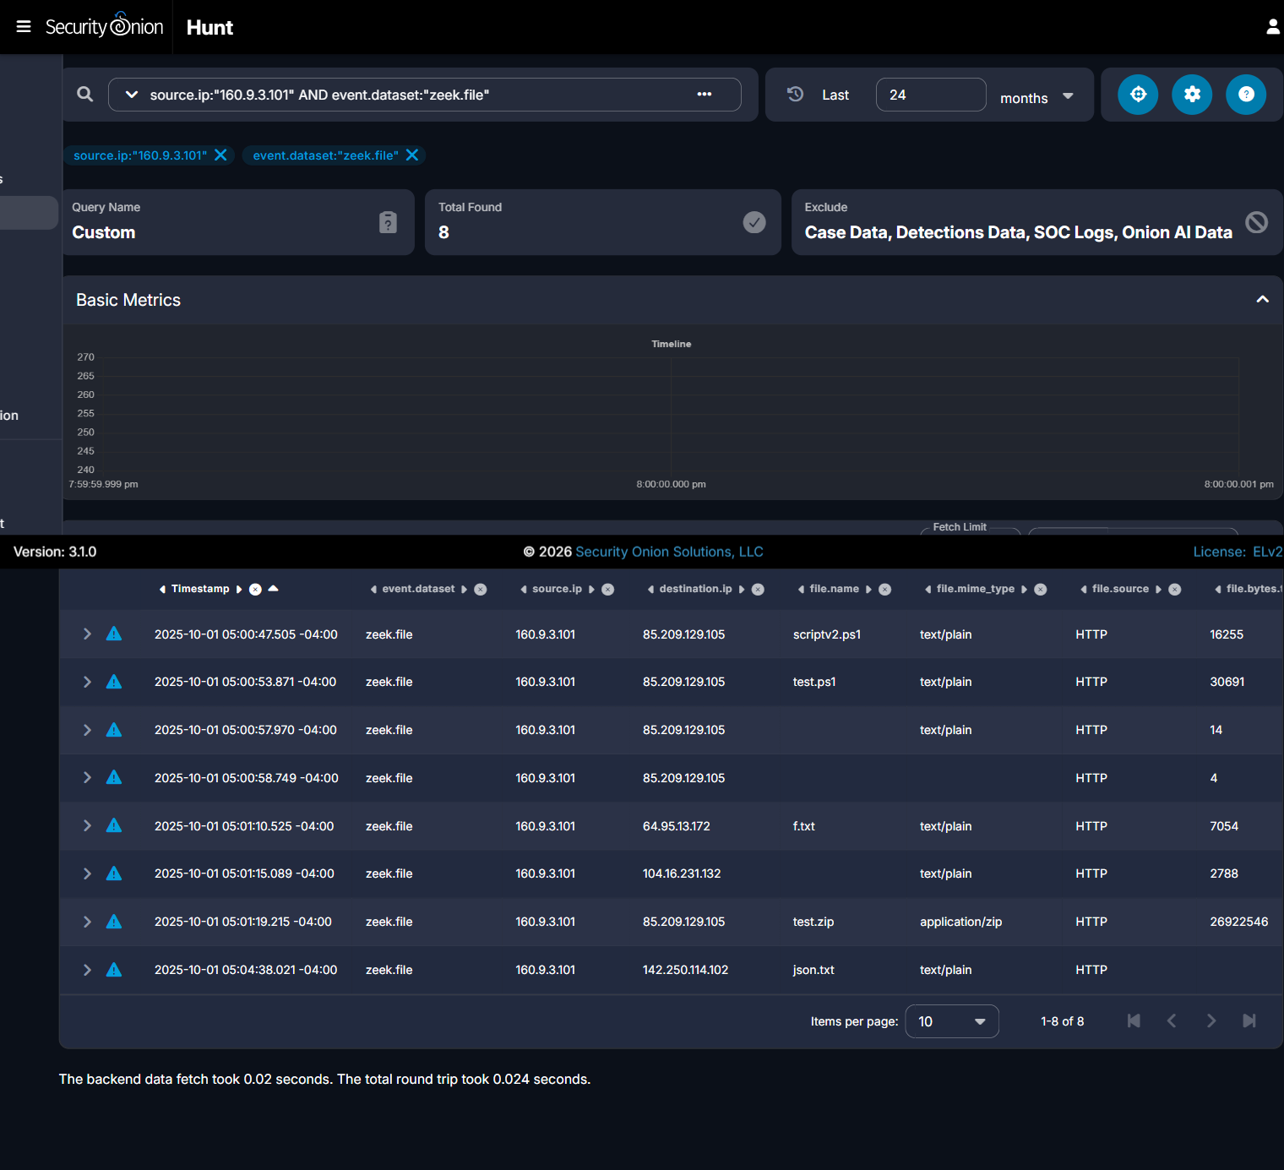

Step 2 - Expand one script's record to confirm the exact server and port
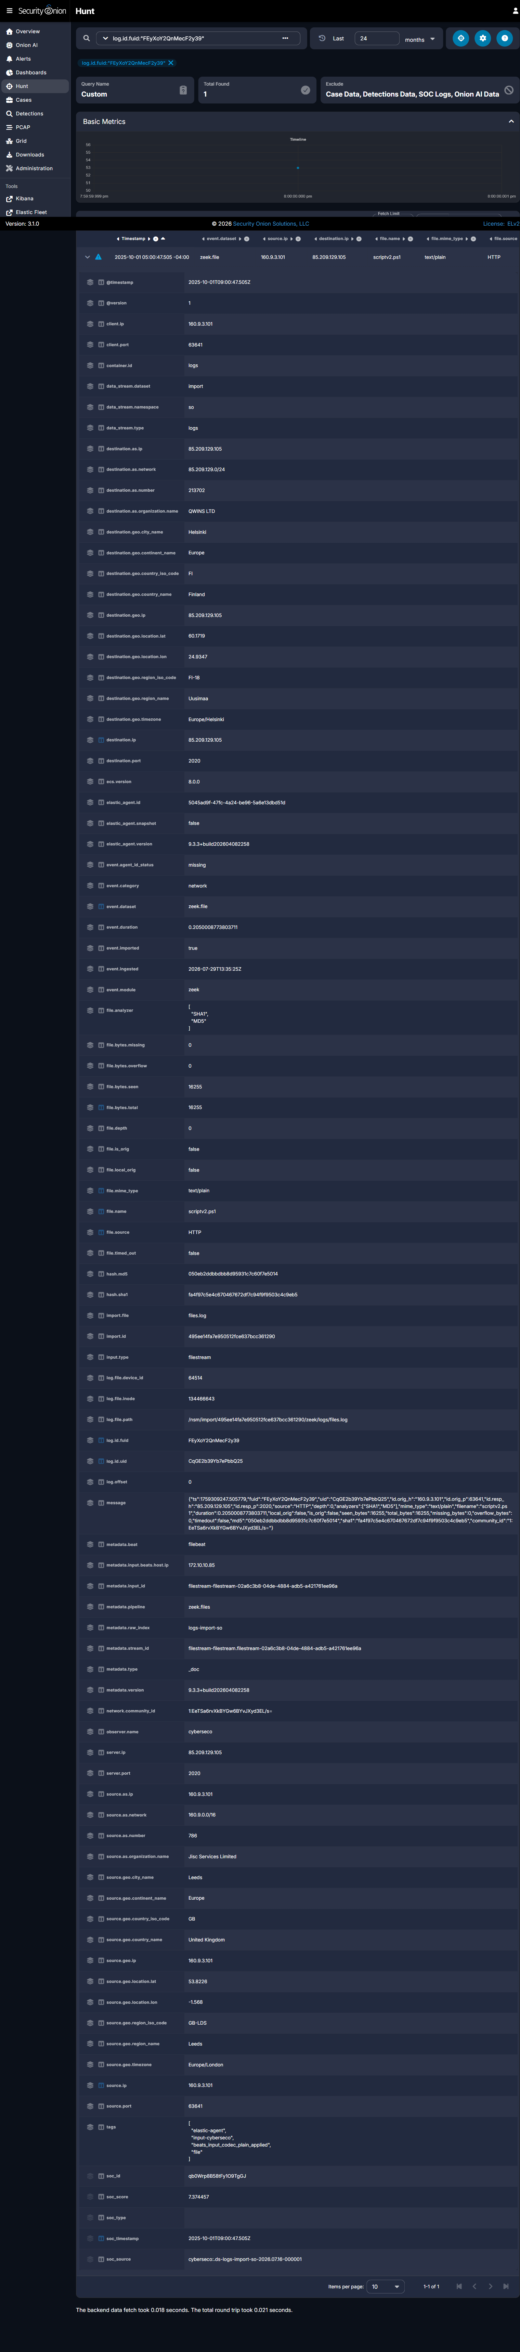

Problem 05 of 10 -- First Script Delivery
Question: What exact web address delivered the very first malicious script, and what was that file called?

In plain terms
The first harmful file was named scriptv2.ps1. It is a small program written for Windows PowerShell (a tool built into Windows for running commands). It was fetched from a specific spot on the bad computer called /19.

Technical method
Query: source.ip:"160.9.3.101" AND event.dataset:"zeek.http". The first request to the delivery server (09:00:47 UTC) is a GET to /19, using the curl tool, returning a file recorded as scriptv2.ps1.

Answer
URI: /19 | Filename: scriptv2.ps1
Submitted flag: CTK{/19|scriptv2.ps1}
Status: CONFIRMED CORRECT -- accepted by the challenge platform.

Step-by-step evidence
Step 1 - List all web requests the victim computer made to the delivery server
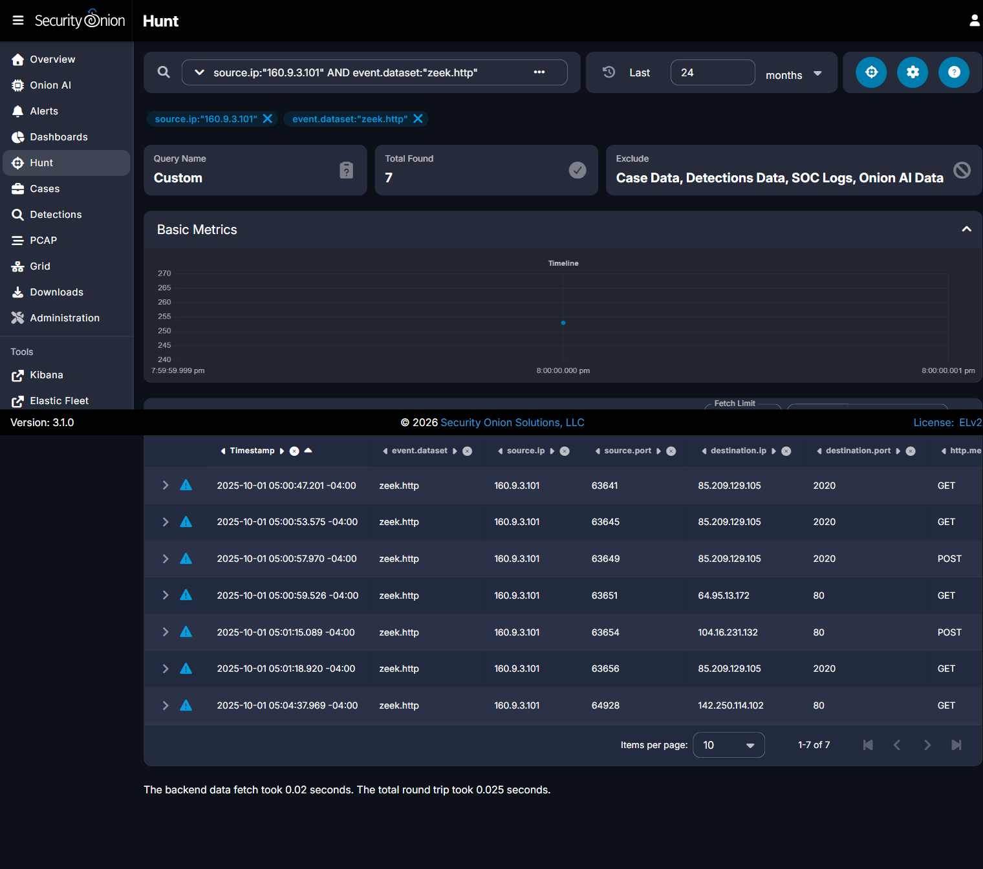

Step 2 - Expand the very first request to read its exact address and filename
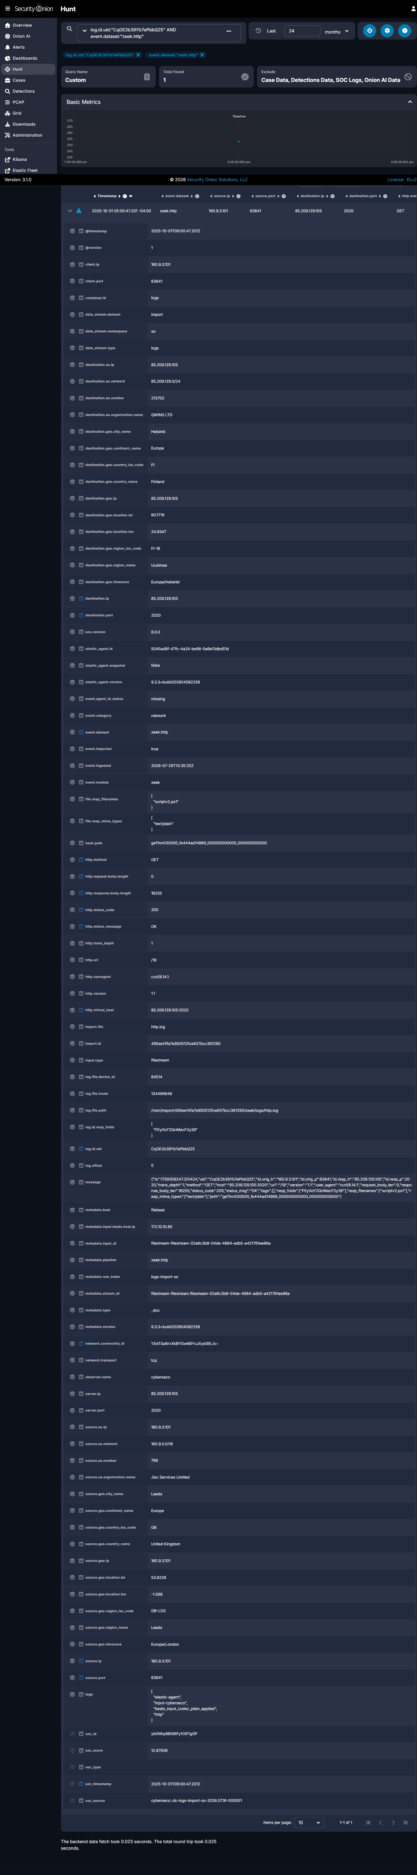

Problem 06 of 10 -- Second Script Delivery
Question: What exact web address delivered the second malicious script, and what was it called?

In plain terms
A second harmful file came next, named test.ps1. It came from a spot called /test112. This time, it was Windows PowerShell itself - not a simple download tool - that fetched it, which tells us the first file had already started running on its own.

Technical method
Query: source.ip:"160.9.3.101" AND event.dataset:"zeek.http". The second request (09:00:53 UTC) is a GET to /test112, this time with a genuine WindowsPowerShell/5.1 user-agent, returning test.ps1.

Answer
URI: /test112 | Filename: test.ps1
Submitted flag: CTK{/test112|test.ps1}
Status: CONFIRMED CORRECT -- accepted by the challenge platform.

Step-by-step evidence
Step 1 - List all web requests the victim computer made to the delivery server


Step 2 - Expand the second request to read its exact address and filename
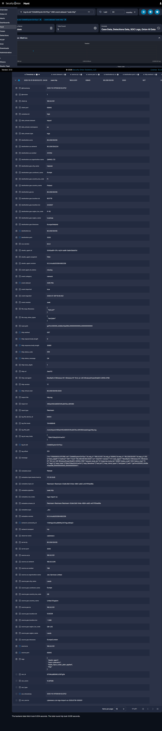

Problem 07 of 10 -- Notification Request
Question: After the scripts ran, how did the victim computer 'report back' success, and what happened?

In plain terms
After the files ran, the victim's computer sent a tiny message back to the bad computer, almost like saying 'it worked!' The message went to a spot called /notify, and the bad computer answered back 'OK' (in computer terms, this is called a 200 status).

Technical method
Query: source.ip:"160.9.3.101" AND event.dataset:"zeek.http". At 09:00:57 UTC, a POST request to /notify sent only 14 bytes and received a 4-byte reply with status 200 OK - a classic small check-in/beacon pattern.

Answer
Method: POST | URI: /notify | Response Status: 200
Submitted flag: CTK{POST|/notify|200}
Status: CONFIRMED CORRECT -- accepted by the challenge platform.

Step-by-step evidence
Step 1 - List all web requests the victim computer made to the delivery server


Step 2 - Expand the check-in request to confirm method, address, and response code
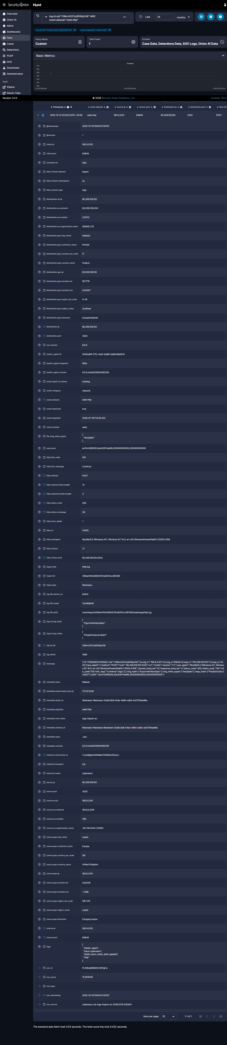

Problem 08 of 10 -- Cloudflare Tunnel Transaction
Question: What temporary Cloudflare 'tunnel' address did the computer briefly use, and what happened?

In plain terms
The attacker also used a free, temporary 'tunnel' from Cloudflare (a real, trusted company) to hide where they truly were. It was used only once. The far end answered 'not found' (called a 404 status).

Technical method
Query: source.ip:"160.9.3.101" AND event.dataset:"zeek.http". At 09:01:15 UTC, a POST request went to maintaining-shelter-bailey-ordinance.trycloudflare.com at URI /BSVjy5VpVrgO, receiving a 404 Not Found response.

Answer
Hostname: maintaining-shelter-bailey-ordinance.trycloudflare.com | URI: /BSVjy5VpVrgO | Status: 404
Submitted flag: CTK{maintaining-shelter-bailey-ordinance.trycloudflare.com|/BSVjy5VpVrgO|404}
Status: CONFIRMED CORRECT -- accepted by the challenge platform.

Step-by-step evidence
Step 1 - List all web requests the victim computer made around this time


Step 2 - Expand the tunnel request to confirm hostname, address, and response code
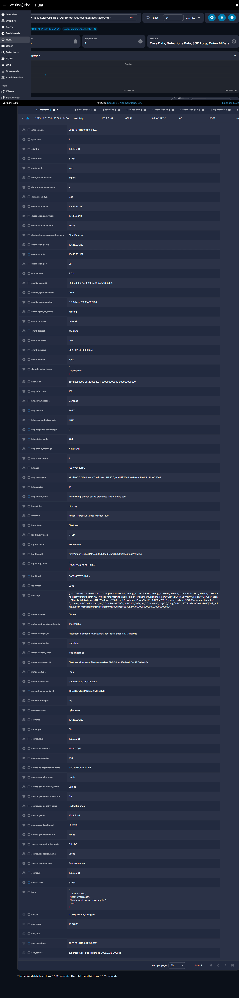

Problem 09 of 10 -- Large Archive Transfer
Question: What web address delivered the large file, what was it called, and exactly how big was it?

In plain terms
The biggest file sent was a large zipped folder - about 26 megabytes, roughly the size of a few hundred photos - named test.zip. It came from a spot called /testl11.

Technical method
Query: source.ip:"160.9.3.101" AND event.dataset:"zeek.http". At 09:01:18 UTC, a GET request to /testl11 returned a 200 OK response with a body of exactly 26,922,546 bytes, matching the file record for test.zip.

Answer
URI: /testl11 | Filename: test.zip | Size: 26,922,546 bytes
Submitted flag: CTK{/testl11|test.zip|26922546}
Status: CONFIRMED CORRECT -- accepted by the challenge platform.

Step-by-step evidence
Step 1 - List all web requests the victim computer made to the delivery server


Step 2 - Expand the archive download request to confirm address, filename, and exact size
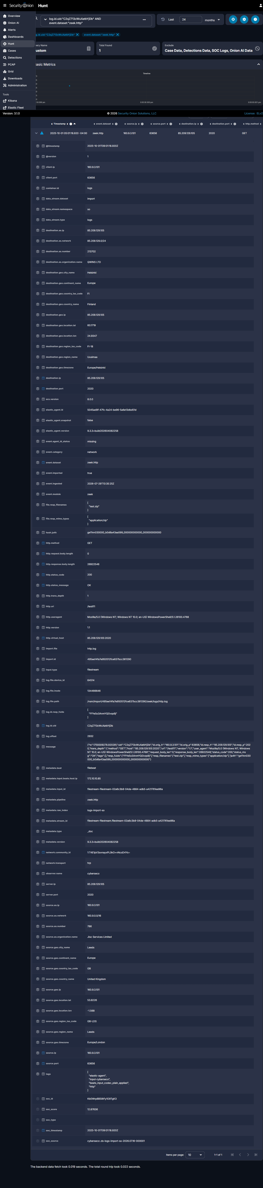

Problem 10 of 10 -- Later TLS C2 Domain
Question: After everything else, which website kept getting contacted over and over - likely the attacker's remote-control channel?

In plain terms
After everything else happened, the victim's computer kept quietly calling out to a website named georgej.ru, again and again - nine times in under a minute. This kind of repeated, automatic calling out is how attackers secretly stay in control of a computer they have hacked.

Technical method
Query: source.ip:"160.9.3.101" AND destination.ip:"91.212.166.160" AND event.dataset:"zeek.ssl". Found 9 TLSv1.3 sessions between 09:04:35 and 09:05:06 UTC, all with server_name georgej.ru.

Answer
Domain: georgej.ru (resolves to 91.212.166.160)
Submitted flag: CTK{georgej.ru}
Status: CONFIRMED CORRECT -- accepted by the challenge platform.

Step-by-step evidence
Step 1 - List every secure connection to the suspicious IP address
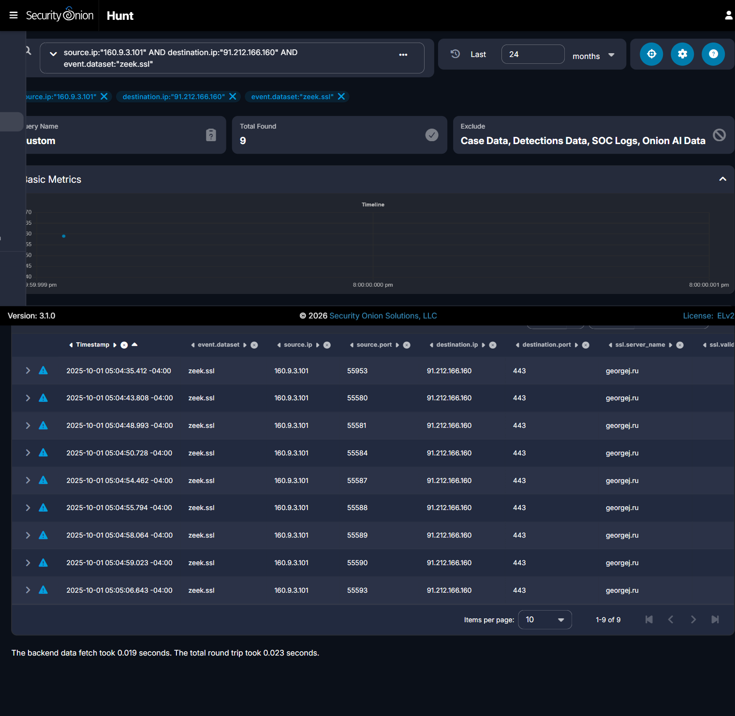

Step 2 - Expand one session to confirm the domain name tied to that address
